## DASHBOARD OF COOKIES DATASET

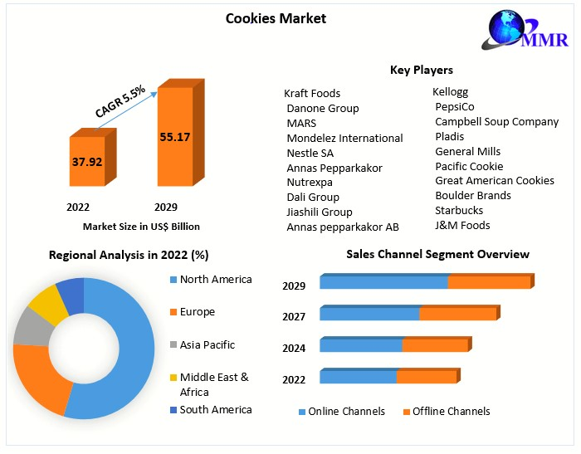

35000

30000

25000

20000

15000

2019

2020

10000

5000

0

Fortune Sugar Fortune Sugar Fortune Sugar Fortune Sugar Fortune Sugar

Cookie Cookie Cookie Cookie Cookie

India

Malaysia

Philippines United Kingdom United States



**Average revenue generated by different**

**types of cookies**

**23%**

**22%**

**4%**

**12%**

**22%**

**17%**

Chocolate Chip Fortune Cookie Oatmeal Raisin Snickerdoodle Sugar

White Chocolate Macadamia Nut



**Chocolate Chip**

**23%**

**22%**

**16%**

**21%**

**18%**

India Malaysia Philippines

United Kingdom

United States



900000

800000

700000

600000

500000

400000

2019

300000

2020

200000

100000

0

India

Malaysia

Philippines

United

Kingdom

United States



8000

7000

Ajio

6000

5000

Amazon

Flipkart Meesho Myntra

Nalli

4000

Others

Men

Women

35000

30000

25000

20000

15000

2019

2020

10000

5000

0

Fortune Sugar Fortune Sugar Fortune Sugar Fortune Sugar Fortune Sugar

Cookie Cookie Cookie Cookie Cookie

India

Malaysia

Philippines United Kingdom United States

## Store Dataset Report

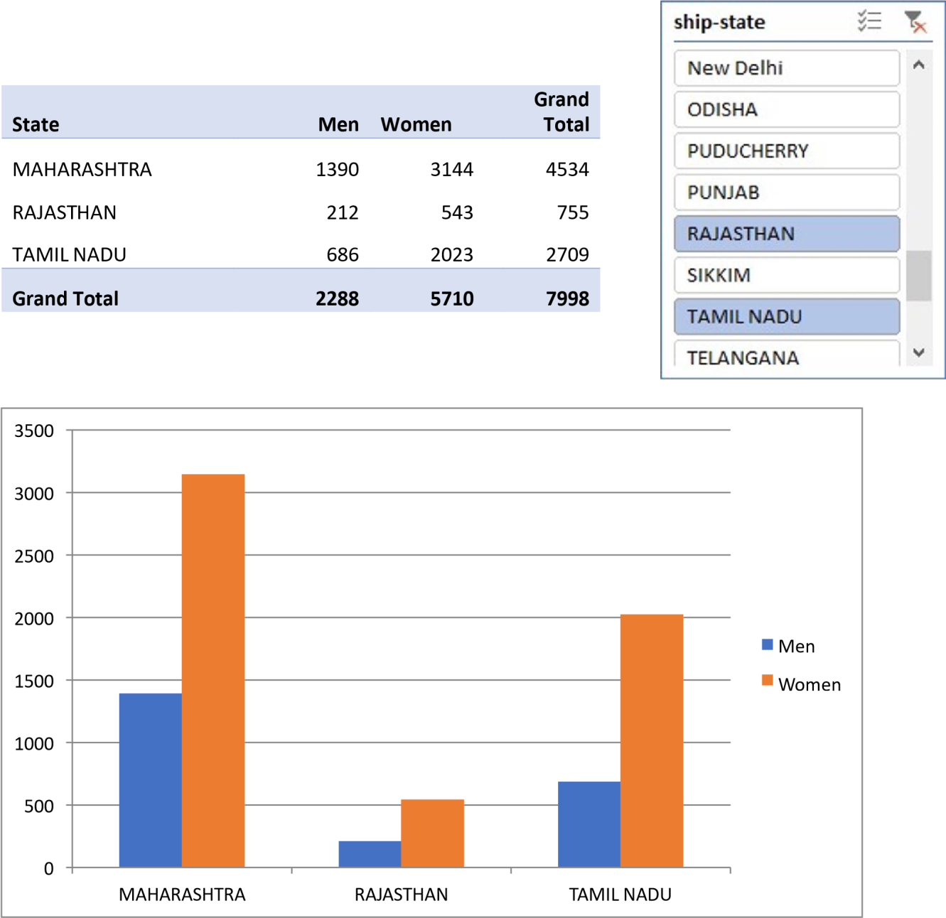

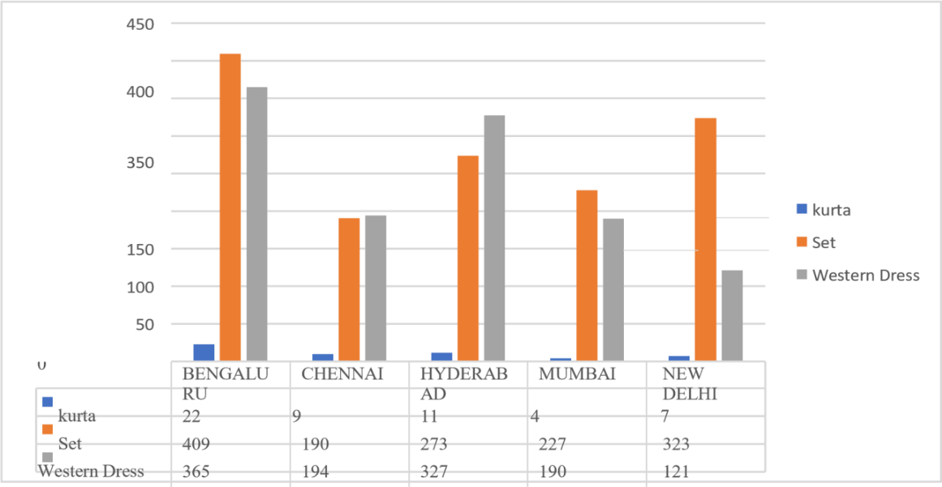

# Exploring Car Dataset



**Corolla vs Chevrolet Mileage**

Chevrolet

228,486

Total

Toyota

277,131

0

50,000

100,000

150,000

200,000

250,000

300,000

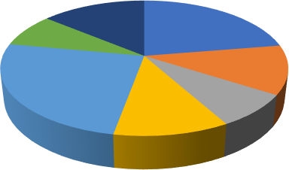

Ford car Vs Honda Car Comparision

Ford Escape Ford F-150 Ford Fusion Ford Mustang Honda Accord Honda Civic Honda CRV



**Color count**

7

6

6

6

5

4

3

3

3

3

3

2

1

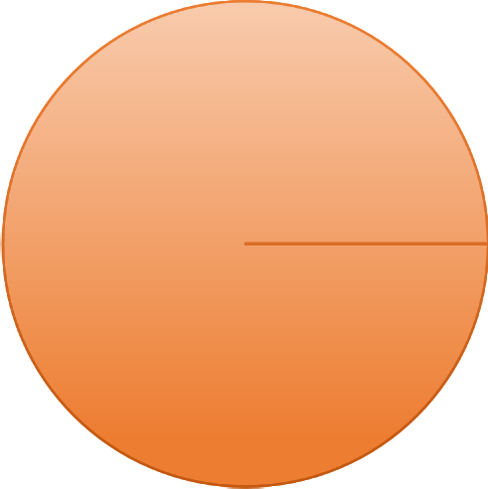

**Green Vs Silver Color Car Mileage Comparision**

100%

100%

Total

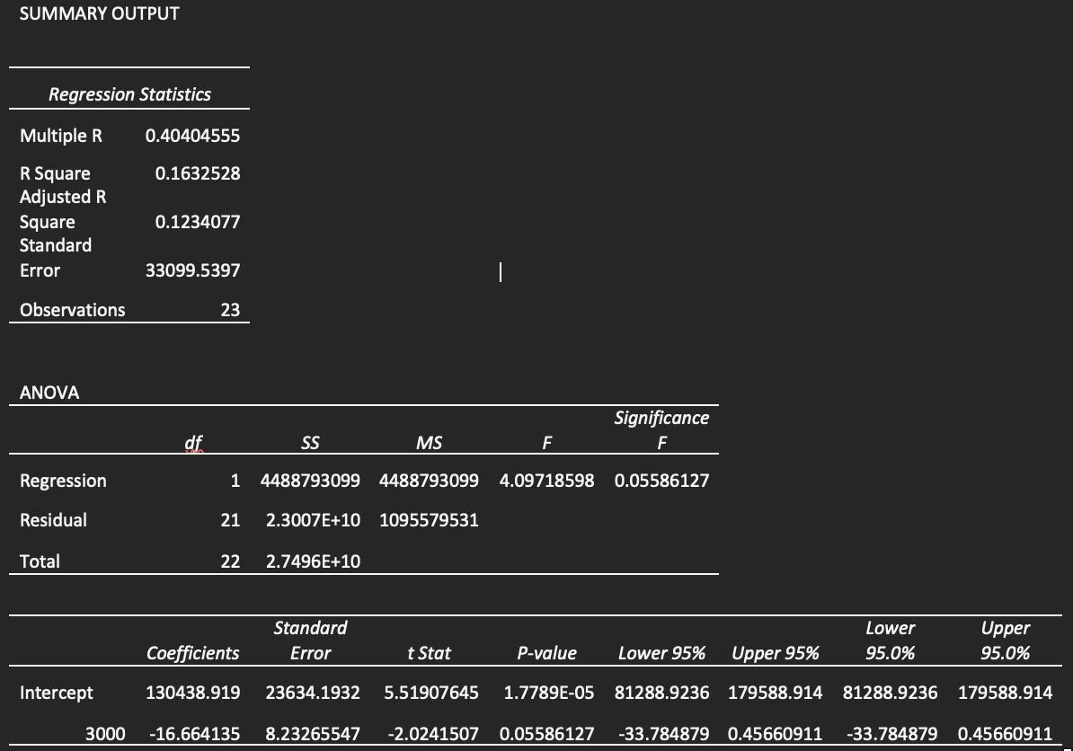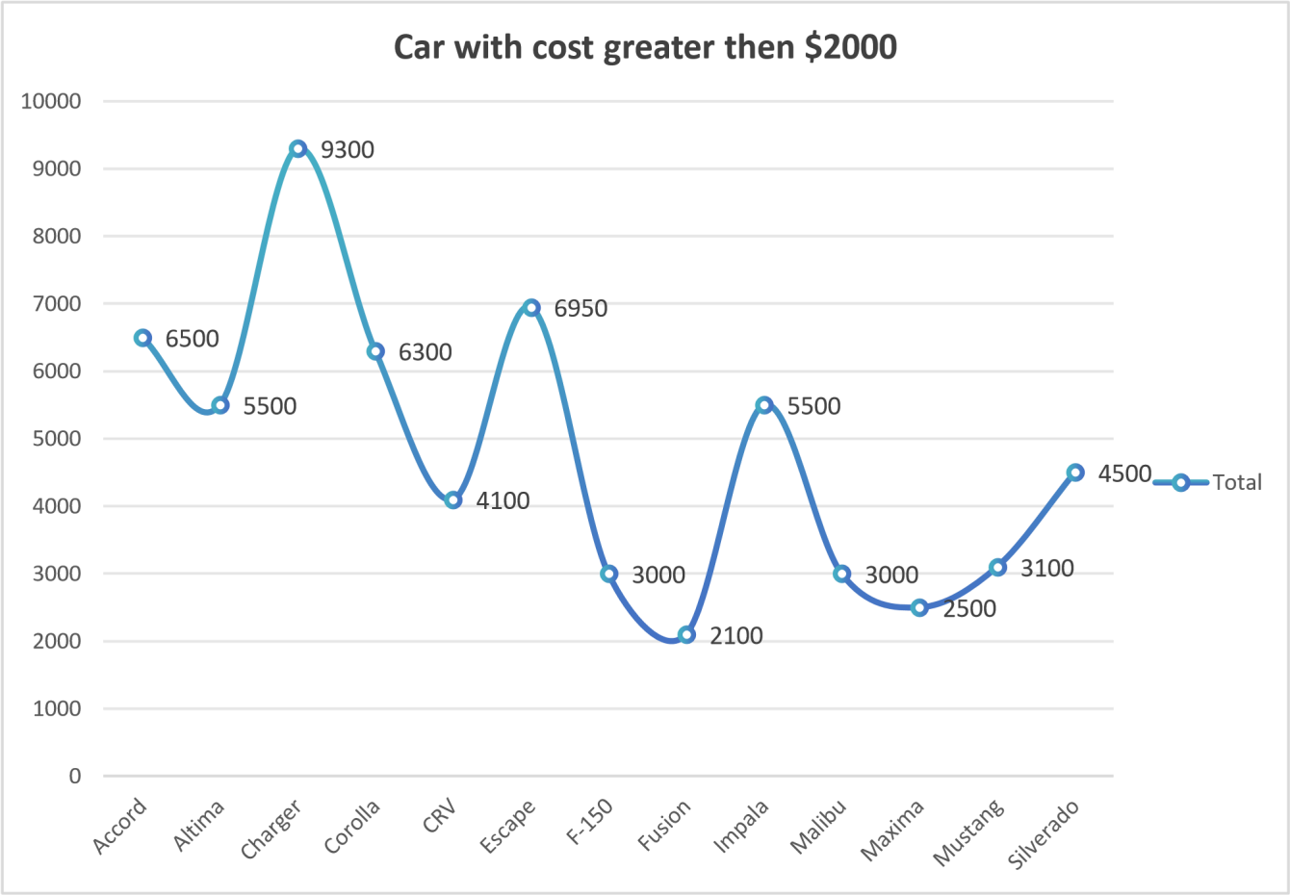

# Exploring sales on different states of US

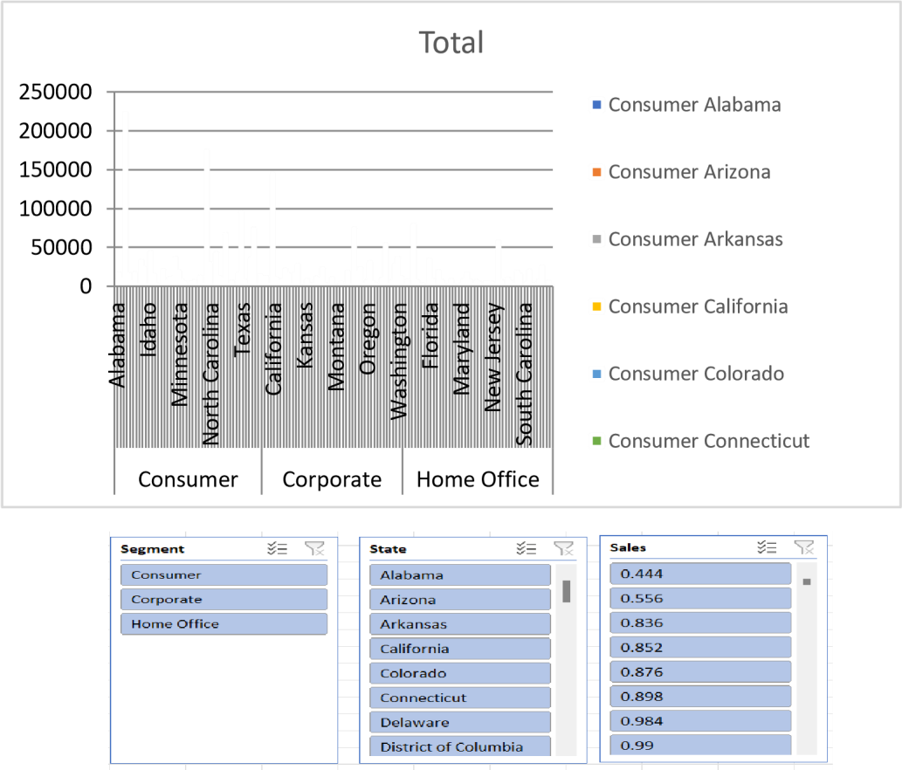

**Total**

Furniture Office Supplies Technology



688494.0748,

30%

424982.1769,

19%

Consumer

424982.1769,

19%

Corporate

Home Office

1148060.531,

51%



2500

2000

**Chart Title**

1500

1000

500

0

sub category

category



**Graduate UnMarried Male Loan Data**

66

Male

Count of LoanAmount

240

Max of LoanAmount

0

50

100

150

200

250

300

Loan Dataset Report



**NonGraduate UnMarried Male Loan Data**

199, 100%

199, 100%

Male



**Graduate UnMarried Female Loan Data**

Female

300

35

84%

86%

88%

90%

92%

94%

96%

98%

100%

Max of LoanAmount

Count of LoanAmount



**Graduate Married Female Loan Data**

500

450

400

350

300

250

200

150

100

50

0

460

~~21~~

Max of LoanAmount

Count of Gender

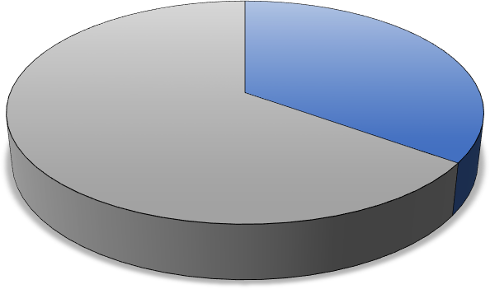

**UNMARRIED MALE AND FEMALE lOAN**

Female Male

44

82

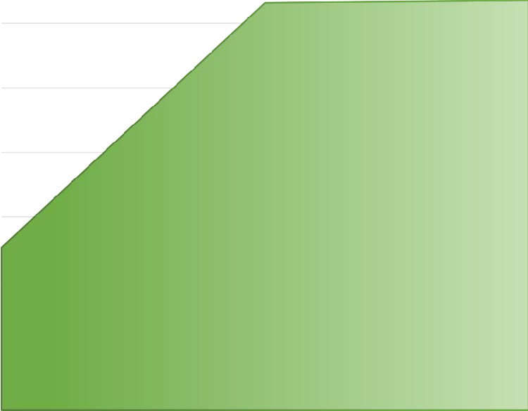

**COMPARISION OF LOAN AMOUNT OF BASIS OF**

**PROPERTY AREA**

5200

5150

5100

5050

5000

5165

5167

Total

4950

4976

4900

4850

Rural

Semiurban

Axis Title

Urban

# Shop Sales Data

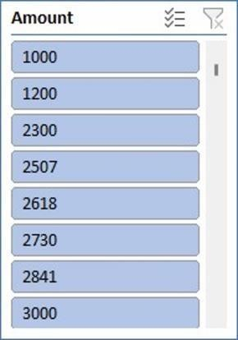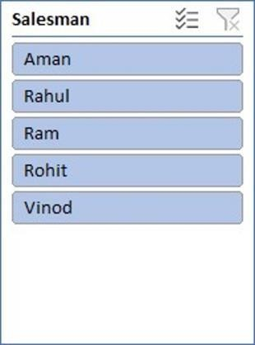

Comparing salesmen on the

basis of Profit Earned

500000

480000

460000

440000

420000

400000

380000

360000

414776.44

47

Total

Aman Rahul Ram Rohit Vinod

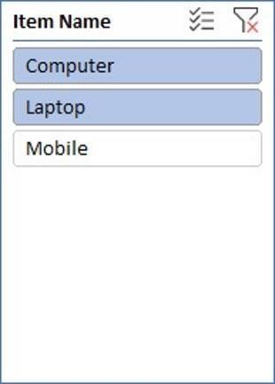

**Total**

**52%**

**48%**

Computer

Laptop

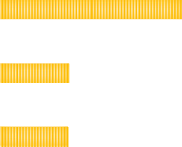

**AVERAGE SALES**

Mobile

Laptop

Total

Computer

6600

6800

7000

7200

|  |  |
| --- | --- |
| **MOST AVERAGE PROFIT**  Total  COMPUTER LAPTOP MOBILE |  |

Sales Data Samples

